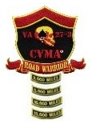
CVMA® 27-3
Road Warrior Program
Road Captain Mileage and Attendance

EVENT NAME: DATE:

ROAD CAPTAIN: ________________________ TAIL GUNNER:

The following members of VA 27-3 participated in this event:

The Official Total Mileage is:

Number of Bikes: ____________________

Signature

