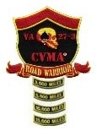

Combat Veterans Motorcycle Association®
VA 27-3
Road Warrior Program Enrollment Form

NAME: ________ DATE:

ROAD NAME: ________

I am enrolling in the CVMA® 27-3 Road Warrior Program (RWP).

I have read the CVMA® 27-3 Road Warrior SOP, and I understand that the program has an annual requirements and a mileage component.

I understand that I am responsible to ensure that the Chapter's Road Warrior Tracking sheet is kept current of my mileage and the annual requirements as I complete them.

I am enclosing my $25.00 enrollment fee that covers the cost of all patches and rockers that I will earn in the RWP.

Signature

