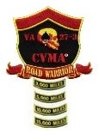
CVMA® 27-3
Road Warrior Program
Road Captain Mileage and Attendance

Event name |  | Date

Road Captain |  | Tail Gunner

The following members of VA 27-3 participated in this event:
Rider | Passenger | Mileage

Number of bikes |  | Official Total Mileage

Signature

